Strategic reinforcement for the management board

Carina Tüllmann becomes new CCO of the Open Logistics Foundation
Monday, 1 September 2025
The Open Logistics Foundation has appointed Carina Tüllmann as the new Chief Commercial Officer (CCO). From 1 September 2025, she will, in addition to communications and community management, also be responsible for human resources development and business development within the Foundation.

On 1 September, Carina Tüllmann will take on the new position of Chief Commercial Officer (CCO) at the Open Logistics Foundation. With her expanded role, she will contribute to strengthening the Foundation’s management and complement the existing leadership team of Andreas Nettsträter (CEO) and Thorsten Hülsmann (CFO). Tüllmann previously served as Chief Operating Officer (COO) and has been part of the team of the European organisation based in Dortmund from the very beginning. In her new function, she will continue to be responsible for the Foundation’s strategic communications as well as the further development of community management. In addition, she will assume responsibility for human resources development and business development – two central areas for the further growth and professionalisation of the organisation.

“I am convinced that we need to rethink communications in the open source world,” explains Carina Tüllmann. “It is not the individual solution that is at the forefront, but the collective process, the people behind it and the open discourse. My goal is to make this dynamic visible both within the industry and beyond.”

In her new role, Tüllmann will intensify dialogue with the member companies and the open source community. The focus will be on active community management, the expansion of international networks, and the continuous integration of new partners to advance open source solutions across company boundaries. In her previous role as COO, she accompanied numerous central projects: from the digital consignment note (eCMR) to the initiation of new Working Groups, such as the one on decarbonisation of logistics.

“Openness, trust and genuine participation are the keys to the digital transformation of our industry,” emphasises Tüllmann. “The role of CCO gives me the opportunity to anchor these values even more firmly in the community and throughout the entire network.”

Further information on the Open Logistics Foundation at openlogisticsfoundation.org

Scope: 2,355 characters without spaces
Images: 1, © Open Logistics Foundation

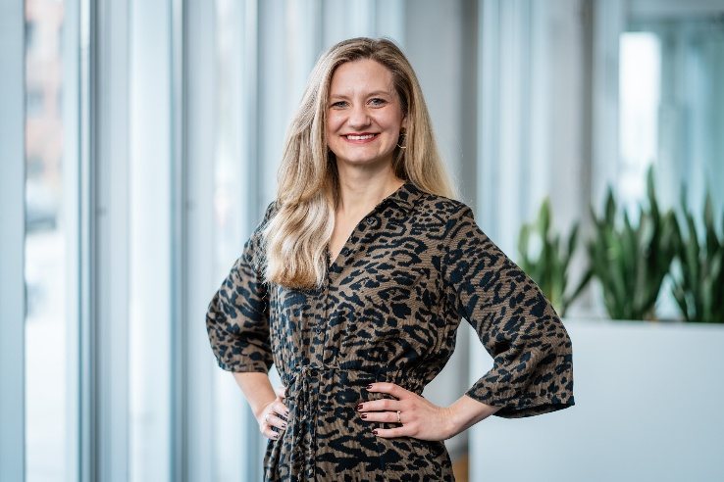
Image 1: Carina Tüllmann, new CCO of the Open Logistics Foundation.

About
The Open Logistics Foundation and its supporting association Open Logistics e.V. were founded in 2021 and are independent and neutral organisations. The non-profit and commonbenefit foundation based in Dortmund is completely financed by industry partners and is dedicated to the voluntary development of innovative open source solutions at a commodity level for the logistics industry. The focus is on open and fair cooperation between different companies, which can also be competitors in the free market. The overarching goal is to solve the most pressing existing problems of the logistics and supply chain management (SCM) community with uniform standards, tools and services, based on open source.

Press contact Open Logistics Foundation
Carina Tüllmann • Open Logistics Foundation
Emil-Figge-Str. 80 • 44227 Dortmund
Phone: +49 (0)173 4120374 • Mail: carina.tuellmann@openlogisticsfoundation.org
Internet: www.openlogisticsfoundation.org

Press contact agency
Maximilian Schütz
additiv
a brand of additiv pr GmbH & Co. KG
B2B communications for logistics, robotics, industry and IT
Herzog-Adolf-Straße 3 • 56410 Montabaur
Tel: +49 (0) 26 02- 950 99-13 • Mail: mas@additiv.de
Internet: additiv.de

This press information, together with further images, is available for download at www.openlogisticsfoundation.org.

Reprint free of charge. Please send us a copy of the publication.

